Using Spacesmasher Test Suite

Chris Sullivan 2014

# Setting up the Project

To set up the project in eclipse right-click on File > Import, the following window will appear.

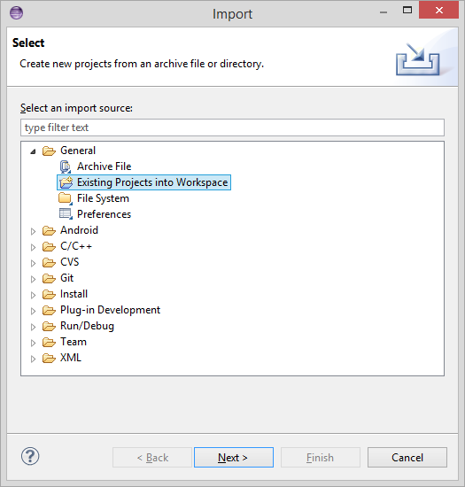

Click Existing Projects into Workspace > Next and the Import screen will open.

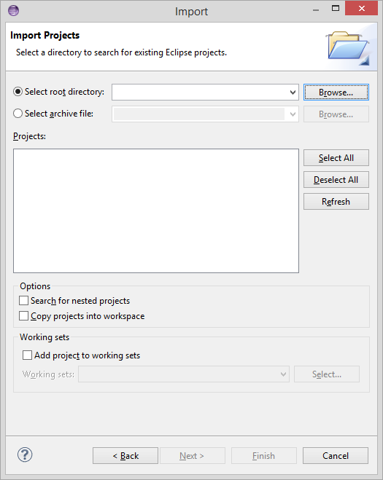

Browse to the root directory where the JUnit Suite is located and click Okay. Under options make sure the Copy projects into workspace is checked and click Finish. SpaceSmasherUnit will now be located in Eclipse’s Package Manager to the left of the Eclipse IDE.

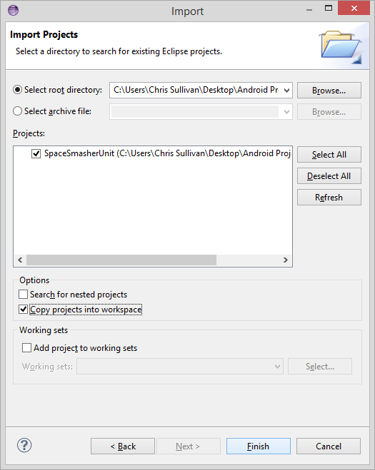

# Importing the API

To test a new API remove the already imported SpaceSmasherAPI from the build path. To do this right click the project > Build Path > Configure Build Path, then select the Libraries tab.

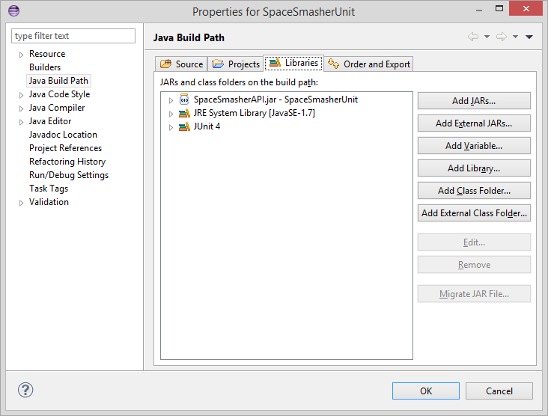

To remove the existing SpaceSmasherAPI select it and then click Remove. To add a new API click the Add External JARs… button and browse to the JAR file.

# Importing an Existing Project

To test an existing project in Eclipse right-click SpaceSmasherUnit > Build Path > Configure Build Path and in the Properties dialog select the Projects Tab.

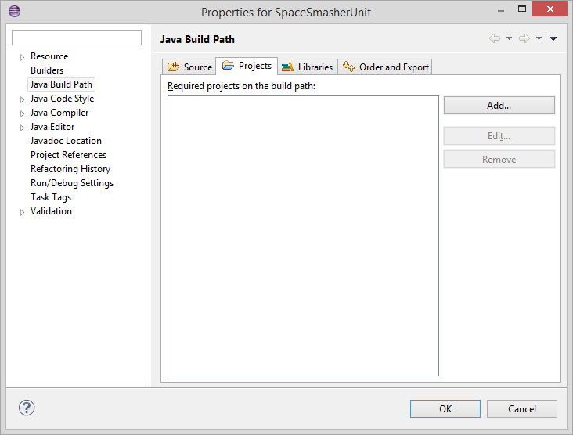

Click the Add… button and select all relevant projects to include in the test, and press Okay on the Required Projects dialog, and Okay again on the Properties Dialog.

# Running the JUnit Suite

Finally to test the included API click on the SpaceSmasherUnit package > tests > runners > and right-click on AllTestRunner. Then select Run As > Java Application.

Output of the test results will be created in the same directory as the SpaceSmasher package, if it is not visible after the tests, right-click the package and select refresh. The output file will be statically named SpaceSmasher JUnit Suite Results.html.

For further questions or help contact Chris Sullivan at themiszelus@gmail.com.